EXPERIMENT 6  
Meet Kansara  
Reg. no.: 220929270  
Roll no.: 54

Example 1:

Write an Energia C/C++ - API interfacing code to establish communication with a known network and obtain an IP address.

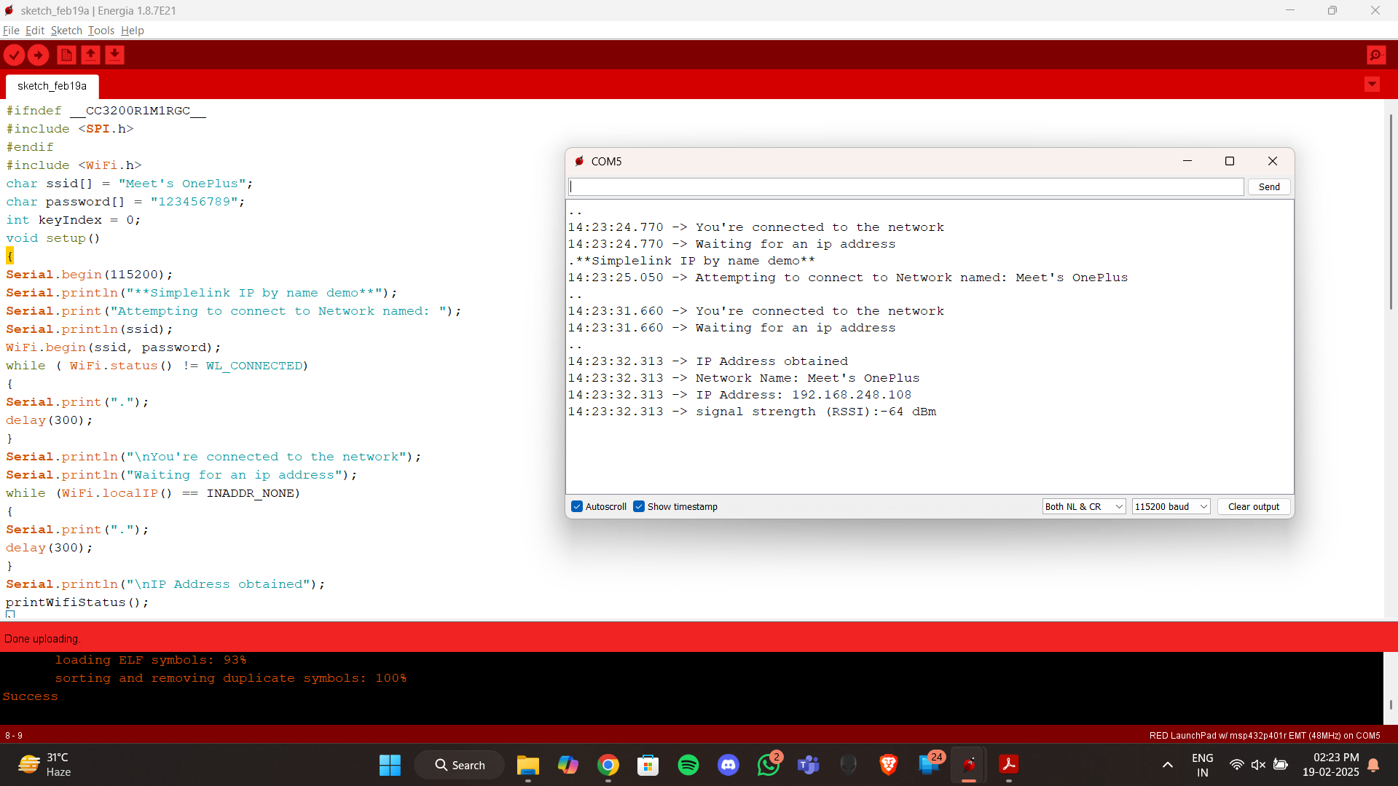

Example 2:

Write an Energia C/C++ - API interfacing code to establish Server – Client Communication.

Exercise 1:

Write an Energia C/C++ - API interfacing code for an industrial automation application through serial monitor.

Condition: In an industry drilling operation has to be done after an inspection operation. The object presence is checked manually by an operator. Pressing ‘R’ the conveyer starts giving an indication through a GREEN LED. Pressing ‘W’, the operation is switched to BLUE LED and an automated press begins for drilling for 5 seconds and then conveyer starts automatically. If in any time of the process the operator decides to stop the operation, then ‘X’ should be the key and should glow RED LED.

NOTE: The whole operation should happen without touching the microcontrollers. The operation is called as a standalone process, one of the most important aspect of IIOT.

